Access Statement for The Royal Yacht Britannia
Updated January 2024
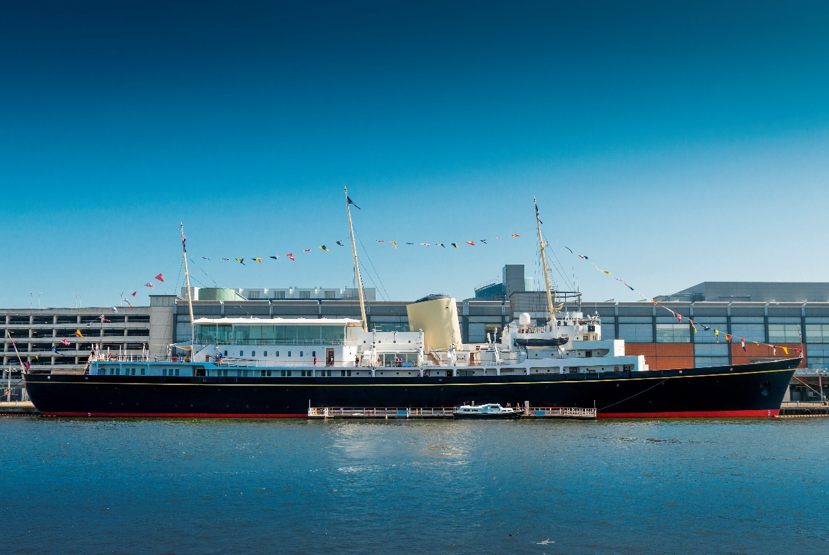
This Access Statement does not contain personal opinions as to our suitability for those with access needs but aims to describe accurately the facilities and services that we offer all our visitors.
The Royal Yacht Britannia, Ocean Terminal, Leith, Edinburgh EH6 6JJ
Please use our postcode for SAT NAV.
For full information on directions, please see our website (www.royalyachtbritannia.co.uk).

The Royal Yacht Britannia is a five-star tourist attraction and exclusive use evening events venue, berthed in Leith, Edinburgh.

Britannia has again been named as Tripadvisor’s No.1 UK Attraction 2023, and has retained its Tripadvisor Travellers’ Choice Best of the Best Award, which is awarded to less than 1% of Tripadvisor’s listings.

The Royal Yacht Britannia is highly accessible for wheelchair users or those with specific access needs. Entry is via Ocean Terminal Shopping Centre, which has a multi-storey car park, including dedicated disabled parking spaces on every level, with lifts connecting all floors.

If you require any further information about specific access or need advice on planning your visit, please contact us:
+44 (0) 131 555 8800 (Monday to Friday 9am – 5pm) or email enquiries@tryb.co.uk.
If we have not covered your access requirements in this document, please contact us and we will be happy to discuss your needs and offer assistance where we can.

Contents
Access Statement for The Royal Yacht Britannia 1
General Information 7
About us 7
Getting here 9
Pre-Arrival 9
By rail 10
By tram………………………………..……………………………..10
By bus…………..…………………………………………………….15
By car..………………………………………………………………..17
By taxi…………..…………………………………………………….17
Outside Ocean Terminal………………………………………..22
Within Ocean Terminal 23
Lift/Escalator Access 25
Wheelchair users 28
Buggies 28
Main Britannia entrance, Reception and ticketing area 28
Arriving at our Visitor Centre 28
The Tour 31
Signage 33
Britannia Tour (displays, exhibits) 33
Public Access on board 35
Lift tower 35
Onboard lift to the Royal Deck Tearoom 36
Doorways, floor coverings, lighting, stairs, ramps 38
Public Toilets 40
Royal Deck Tearoom 42
Gift Shop 44
Additional Information 48
Wheelchairs 48
Assistance Dogs 48
Staff training 49
First Aid 49
Smoking Area 50
Local accommodation providers 50
Feedback 51
Contact Information 52

General Information

About us
- We aim to provide the best possible customer experience for everyone.
- Britannia has again been named as Tripadvisor’s No.1 UK Attraction 2023, and has retained its Tripadvisor Travellers’ Choice Best of the Best Award, which is awarded to less than 1% of Tripadvisor’s listings.
- Britannia is berthed in Leith, Edinburgh, just 2 miles from the city centre.
- Access to Britannia is through Ocean Terminal Shopping Centre (2nd floor of the shopping centre itself, most directly accessible from Level E of the Car Park).
- We have British and American Sign language tablets, an audio tour in over 30 languages, Braille script, plus basic English, a version for the visually impaired and a children’s version in English of our tour.
- At the Handset Desk we have straps which allow the audio guides to be worn around the neck. Headphones are also available.
- The audio tour is available to listen to on your mobile phone during the tour. We encourage our visitors to bring their own headphones but disposable headphones are available.
- For opening dates and times, please see our website.
- On average tours last 1.5 – 2 hours, but please allow longer if using our Royal Deck Tearoom.
- We have accessible toilets within the Visitor Centre and aboard Britannia.

Getting here
- You can arrive at Ocean Terminal by car, tram, bus, bicycle, taxi or on foot.
- There is a multi-storey car park. Parking is free.
- The nearest dedicated parking for wheelchair users and people with mobility impairments is in the Car Park of Ocean Terminal on Level E.
- There are tram and bus stops situated on Ocean Drive, outside Ocean Terminal Shopping Centre. Trams and buses frequently run to and from the city centre.
- There are bike racks situated at the front of Ocean Terminal.

Pre-Arrival
We are just 25 minutes' drive from Edinburgh city centre. Our Visitor Centre is in Ocean Terminal on the second floor.

By rail
The nearest train station is Edinburgh Waverley, this is 2.3 miles from Ocean Terminal. There is a taxi rank outside the station. It will take around 20-25 minutes by taxi to Britannia from Edinburgh Waverley. This may vary depending on the traffic.

By tram
- Edinburgh Trams now run from Edinburgh Airport through Edinburgh city centre and down to Leith.
- To visit Britannia, get off the tram at the stop ‘Ocean Terminal’. The tram stop at Ocean Terminal is located on Ocean Drive, outside Ocean Terminal Shopping Centre, in the centre of the road.
- All trams feature low entrances.

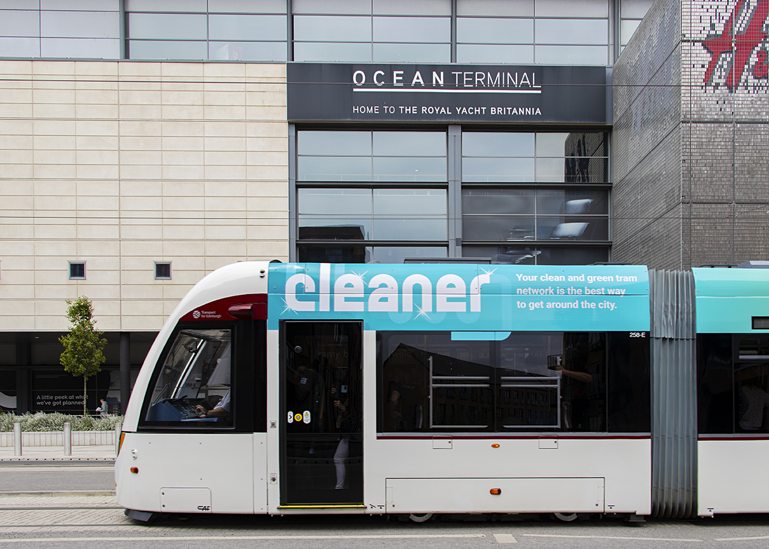

- There is corduroy tactile paving at the tram stops and there is both corduroy tactile paving and a sloping pavement down towards the pedestrian crossing to cross over the road to Ocean Terminal Shopping Centre.
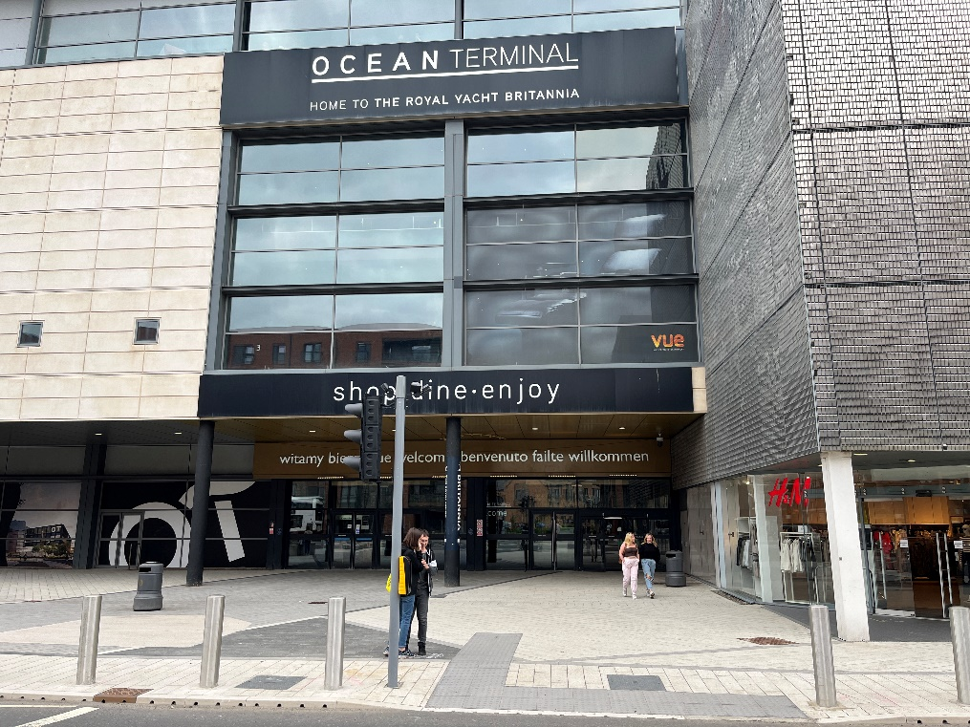

- There are dedicated spaces for wheelchairs and mobility scooters on every tram, located in the middle carriage of the tram. A wheelchair symbol on the tram stop platform indicates where to wait.
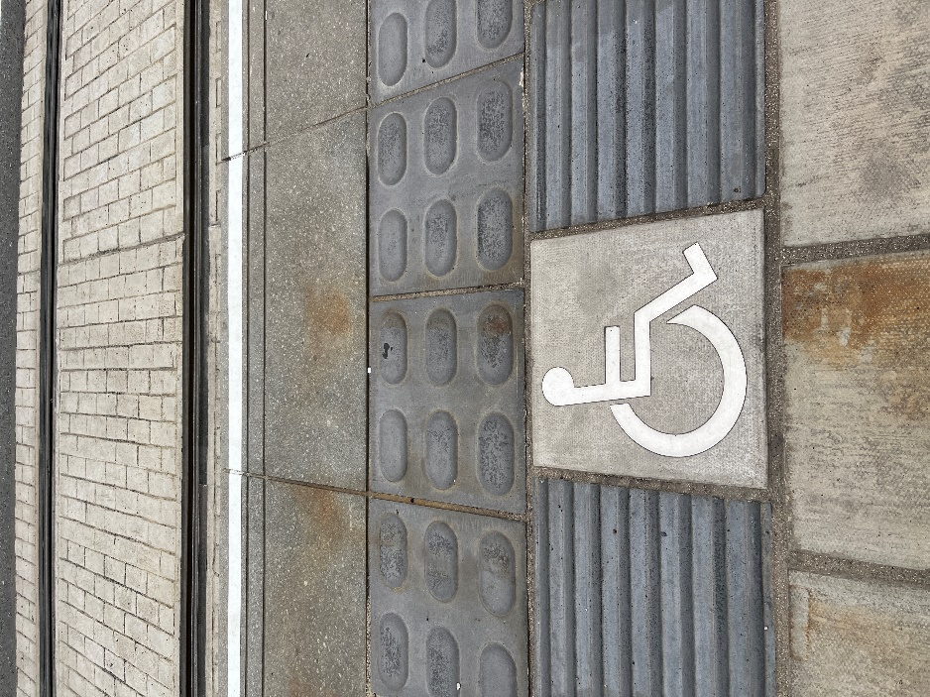
- Due to space limitations, the trams can only accommodate up to Class II mobility scooters.
- A single journey on Edinburgh Trams costs £2.00 each way in the city zone. Child tickets are £1.00 each way. If you are returning to the city, you can purchase a return ticket for the same day at £3.80 for adults and £1.90 for children. Tickets must be purchased from the machines on the platform before travel. Ticket vending machines accept most debit and credit cards including American Express as well as 5p, 10p, 20p, 50p, £1 and £2 coins. No change is given. If you are travelling to or from Edinburgh Airport there is a single ticket for £7.50 or an open return for £9.50.

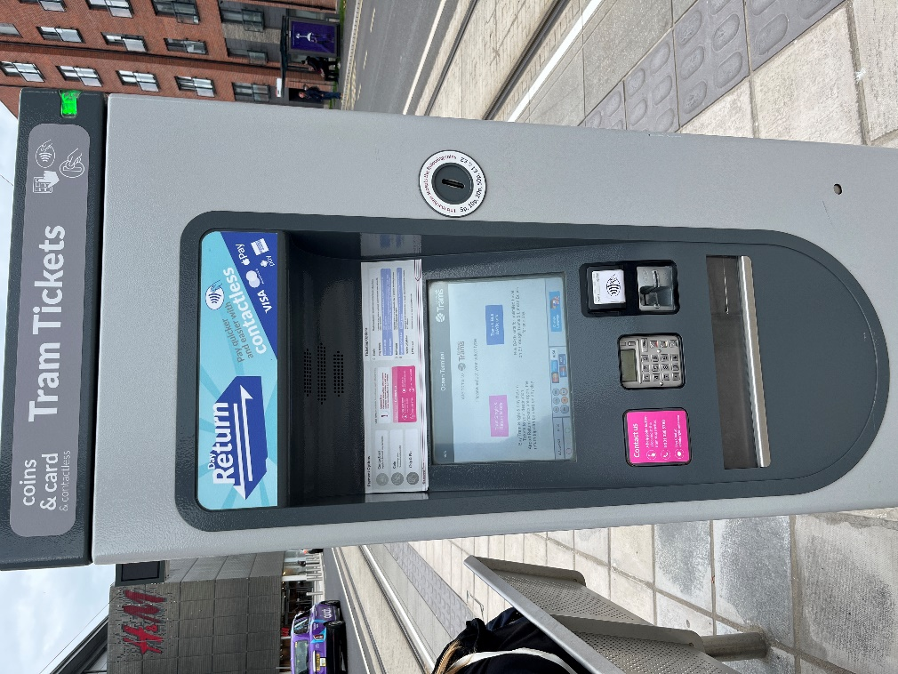

- If you have an Edinburgh Trams Ridacard or citysmart card this must be validated at the grey machine on the tram platform, before boarding. A journey has been deducted when the green tick comes up on screen. You must board within 30 minutes of validation.

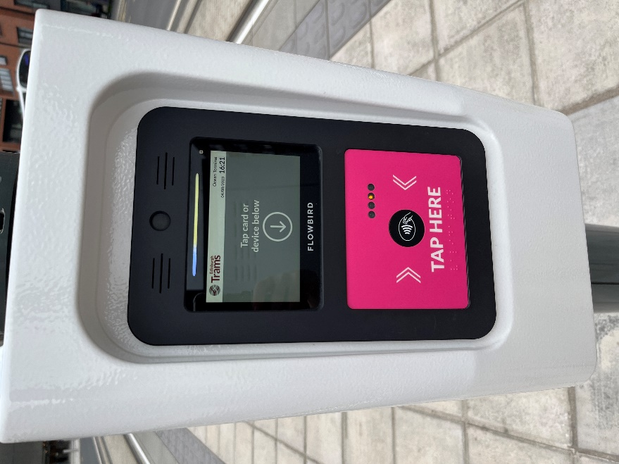

Edinburgh Trams are completely wheelchair accessible
They have:
- Low entrances throughout the vehicle.
- High visibility handrails.
- Two dedicated wheelchair/buggy spaces per tram.
- Dedicated disabled priority seats.
- Passenger alert buttons signposted in Braille for blind and partially sighted tram users.
- You can read more information on the Edinburgh Trams Accessibility page.

By bus
- Lothian Bus services from Edinburgh city centre are numbers 10, 16, 34 or 35.
- The bus stops are located outside Ocean Terminal Shopping Centre, except the number 16 Lothian Bus, which is on Commercial Street. Commercial Street is at the crossroads with Ocean Drive and North Junction Street. The number 16 bus stop for Britannia is outside Leith Job Centre and the number 16 bus stop travelling towards the city centre is on the opposite side of the road to the Leith Job Centre.
- Majestic Tour buses depart from Waterloo Place, just off Princes Street in Edinburgh’s city centre. The Majestic Bus stops outside Ocean Terminal Shopping Centre.
- A single journey on a Lothian Bus is currently £2.00 and a child single journey costs £1.00. Please note you must have the correct amount (no change is given) or use a contactless card. A day ticket is available for £5.00 or capped at £4.80 when the same contactless card is tapped for three or more journeys.

All Lothian buses are easy access
They have:
- Low entrances that can “kneel” to kerb height to give step free access where possible.
- Retractable boarding ramp for wheelchair access.
- High visibility handrails.
- A dedicated wheelchair space.
- Drivers specially trained to help customers enjoy the full benefit of their buses.

By car
For satnav, our postcode is EH6 6JJ. Follow signs for Edinburgh and Leith, or North Edinburgh. Then follow brown Britannia signs. FREE parking at Ocean Terminal (Level E of the car park is nearest to our Visitor Centre and has disabled spaces).

By taxi
There currently is no designated taxi drop-off point. Taxi drivers will drop you off as close to Ocean Terminal as possible.

Our preferred taxi supplier is Central Taxis. All Central Taxis are wheelchair accessible. They offer a mix of 5-seater TX Hackney cabs, 6-seater Mercedes M8 taxis and Peugeot E7 taxis, each of which is supplied with a wheelchair ramp, seatbelts and additional safety anchors. All drivers have completed training in Wheelchair Access and Disability Awareness.

Ocean Terminal Car parking and arrival
There is a multi-storey car park at Ocean Terminal. If arriving to The Royal Yacht Britannia by car, the best level to park on is level E.

Ocean Terminal Free car parking:
Car park level | No. of blue badge car parking spaces
Level C | 22
Level E | 11

The surface of the multi storey car park is concrete. The car park is well lit. On entry to the shopping centre from the multi storey (Level E) there are 2 automatic outward opening doors. The width of these is approximately 1560mm. Each level has two lifts from the car park entrance that service every level of the shopping centre.
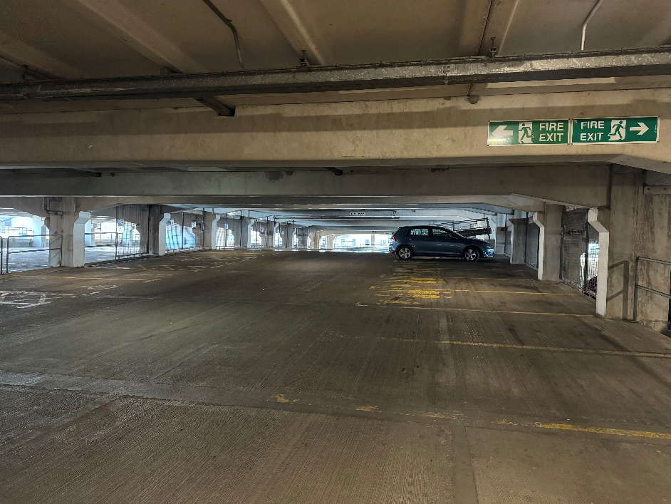
(Ocean Terminal multi-storey parking.)

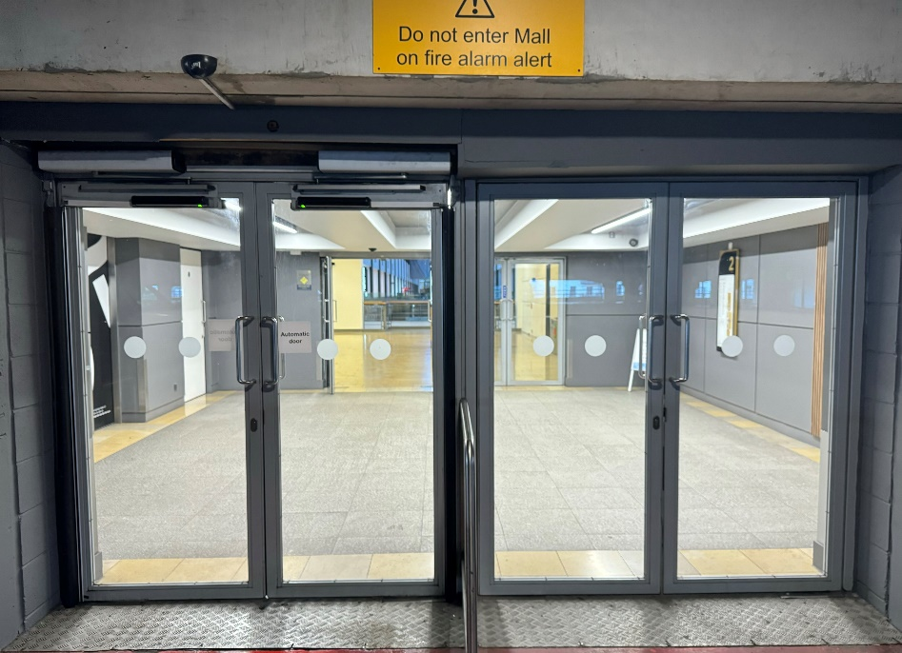
(Ocean Terminal car park, Level E – This is the same level to access Britannia’s Visitor Centre from the car park, with a set of outward facing automatic on the left and manual set of doors on the right, as shown in the above picture.)

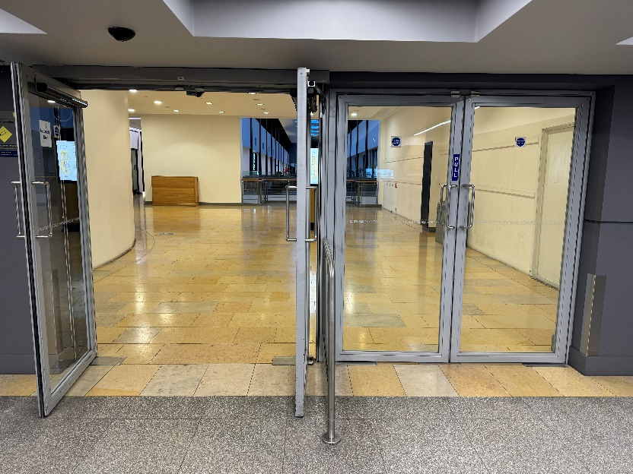
(2nd floor Inner entrance to Ocean Terminal, the second set of automatic doors with an outward automatically opening set of doors on the left and a manually opened set of doors on the right.)

On entry to the shopping centre from Level E, the entrance to our Visitor Centre is approximately 191.5 metres away. The centre is tiled throughout. On entry to our Visitor Centre, the flooring is a smooth wooden surface.

There are three welcome desks on arrival to our Visitor Centre, at least one of which is always staffed. We have hearing induction loops throughout Britannia. There is also complimentary Wi-Fi throughout.

Arriving by bus, tram, taxi, bicycle or on foot
If arriving by bus, tram, taxi or if you are on foot, access to Britannia is from the Ocean Terminal Shopping Centre main entrance on the ground level.

Please note that you will not see Britannia, as the Yacht is permanently berthed behind the shopping centre.

Outside Ocean Terminal (left hand set of doors)

The main entrance to Ocean Terminal is at street level. There are 4 double sets of doors. The first pair of doors on the left open outwards automatically.
The second pair of doors are manual. Each has a width of 1570mm.

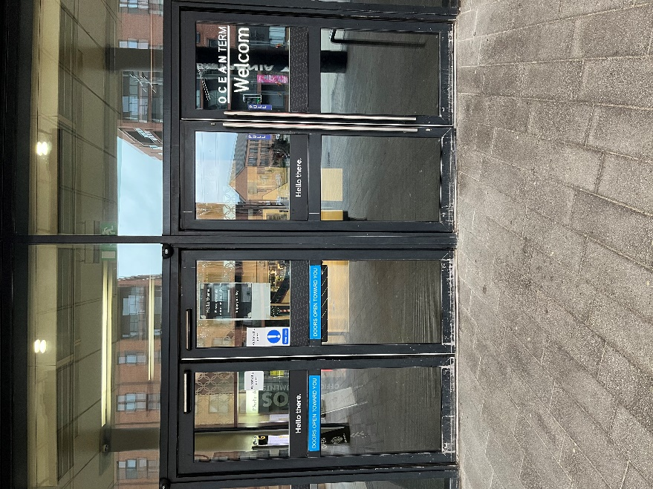
(First set of outer doors to Ocean Terminal. As shown above, the doors on the left open automatically. A set of manually opened doors are shown to the right.)

Within Ocean Terminal (left hand set of doors)

Once inside Ocean Terminal, there is a second set of doors. The pair of doors on the left are opened automatically by a push button. The set of doors on the right are opened manually.

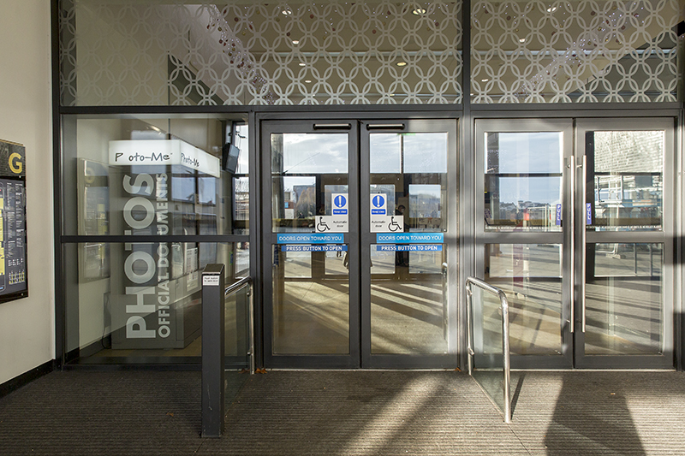
(The inner set of doors inside Ocean Terminal.)

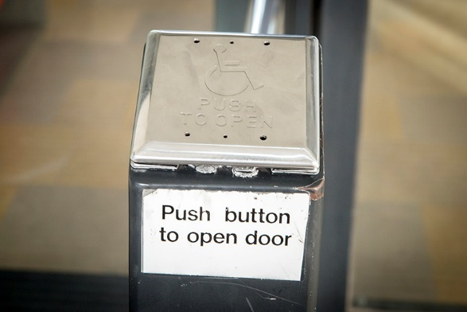
Push button access

(The automatically opened doors on the left are opened by a push button.)

Outside Ocean Terminal (right hand set of doors)

The third pair of doors are manual and the fourth pair of doors are automatic inline sliding doors.

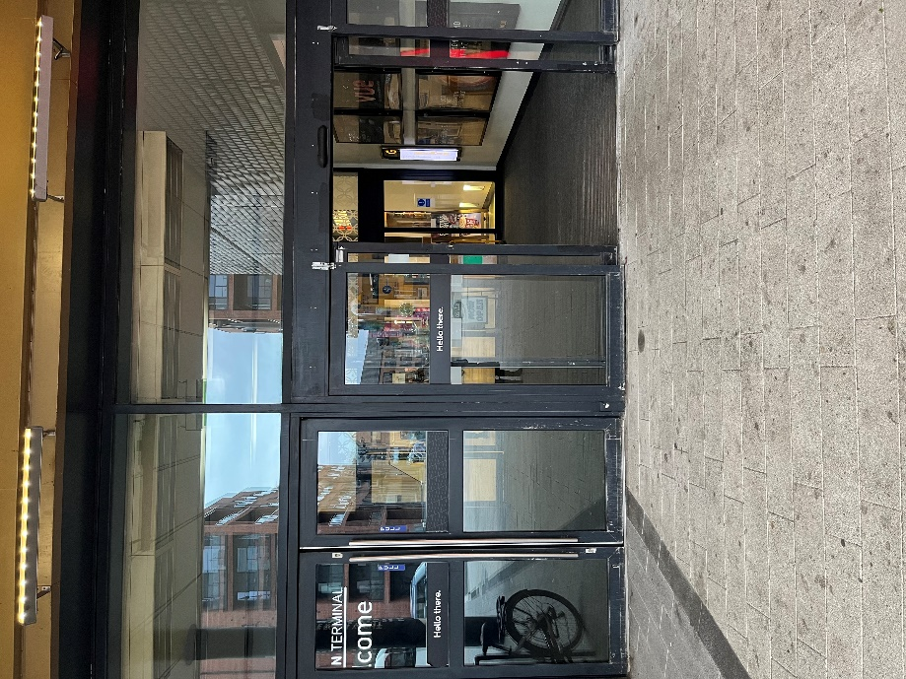

Inside Ocean Terminal (right hand set of doors)
Once inside Ocean Terminal through these doors, there are a pair of manual doors on the left side and a pair of inline sliding doors on the right.

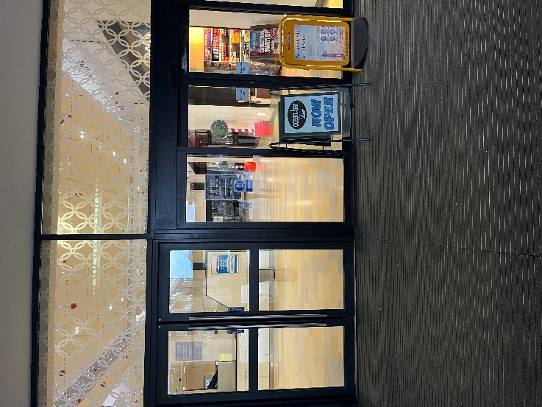
(Within Ocean Terminal there is another set of doors A pair of manual doors on the left and a set of automatic doors slide open on the right hand side.)

Lift/Escalator Access
Through the main entrance to Ocean Terminal, turn right and proceed along the concourse. There is a lift on the far left, which gives access to level 2, where the Britannia Visitor Centre is located. The lift has an induction loop and speaker for emergencies and can take up to 1600kg of weight, maximum 15 people.
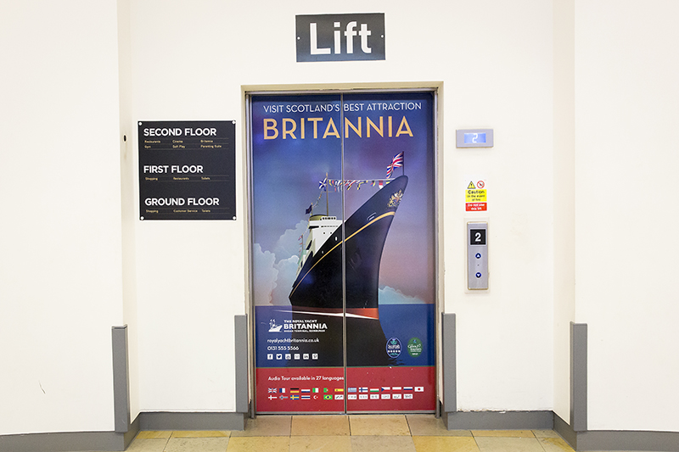
(Lift access to Britannia within Ocean Terminal Shopping Centre. This lift has a width of 1200mm.)

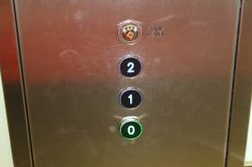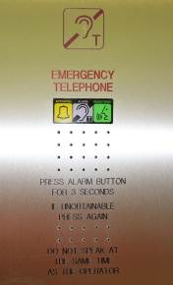
(Left image shows the lift buttons inside the Ocean Terminal lift. The right image shows the emergency telephone within the lift.)

Alternatively, go straight ahead from the main entrance to Ocean Terminal and take the escalators to the 2nd floor to start the tour.

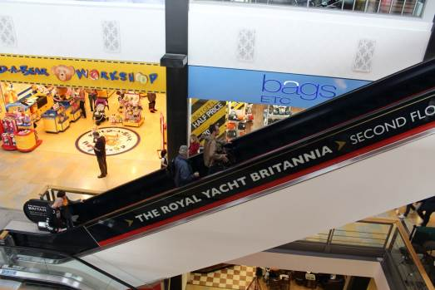
(Escalator from the 1st floor to the 2nd floor.)

Wheelchair users
- Please note: Shopmobility scooters and electric wheelchairs are generally unsuitable on Britannia due to the gradient of the ramps on board.
- Britannia is classed as Category 1, the highest level for wheelchair access without assistance, by VisitScotland. To access the whole tour, wheelchairs should be no wider than 670mm, in order to negotiate some narrow passageways and corners.
- If your wheelchair exceeds 670mm in width, we have five wheelchairs available for your use, at no extra charge. Please ask to use a wheelchair at the ticket desk.

Buggies
- Buggies are welcomed on board Britannia. All but the widest double buggies will have full access to the Britannia tour (max width 670mm). We have baby changing facilities in the Visitor Centre and at the four sets of toilets on board. We have high chairs in the Tearoom.

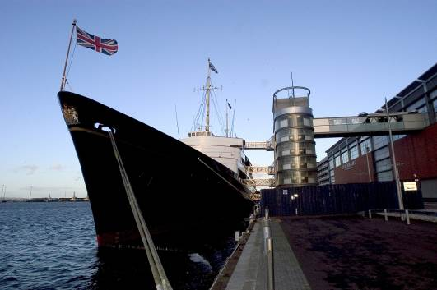
Lift Tower
(The Royal Yacht Britannia, with lift access to five decks via the Lift Tower, pictured above.)

Each of Britannia's decks are accessed via a shore-side Lift Tower and stairwell. Any seats without ropes or signage are there for you to sit on and enjoy your tour.

Main Britannia entrance, Reception and ticketing area

Arriving at our Visitor Centre
On arrival at the 2nd floor of Ocean Terminal, you will find our Visitor Centre near the rotunda at the East end of the building.

Our ticket desk is located to the left of our entrance and our Gift Shop is located to the right.

There are no steps on entry to the Visitor Centre. The floor surface in the Visitor Centre is wooden and short pile carpet. There is seating available on entry to the Visitor Centre and before proceeding on board Britannia. The area is lit well by both compact fluorescent bulbs and LED spotlighting. There is a manned podium at front of house to give information about tickets and the local area.

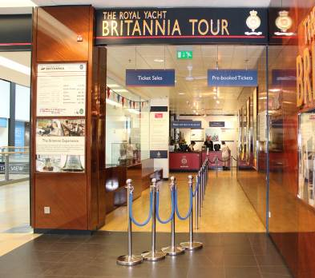
(Visitor entrance to Britannia.)

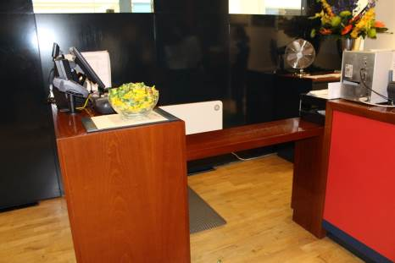
(Lowered desk at our payment desk.)

There is a lower counter area, pictured above, suitable for wheelchair users. The payment/information desks area has a hearing loop.

We can offer a pen and pad of paper to assist people in the ticketing area and also have a magnifying glass available.

Tickets can be purchased for the Britannia tour from the ticket desk, or in advance online via our website – www.royalyachtbritannia.co.uk. Should a complimentary carer ticket be required, this can be requested at the ticket desk on the day.

The Tour
Our audio tour is available in over 30 languages, a Basic English version, a version for the visually impaired and a children’s version in English. Visitors with learning difficulties or those whose first language is not English may find the Basic English audio tour suitable.

The tour is available in British or American Sign Language on a tablet. We also offer the tour in Braille script. We have a printed version of our English language tour in large font – please request this at the Handset Desk before you step on board Britannia.

Our audio handsets have adjustable volume control, so you may wish to also take the handset tour.

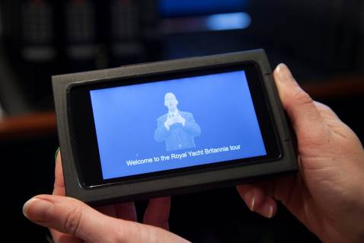
(Britannia’s British Sign Language Tablet.)

We have Visitor Assistants situated throughout our tour, who are on hand to assist our visitors. The Visitor Assistants are smartly dressed in Britannia’s tartan and in colder weather have a red jacket.
Sensory packs are available from the Handset desk, similar to as pictured.
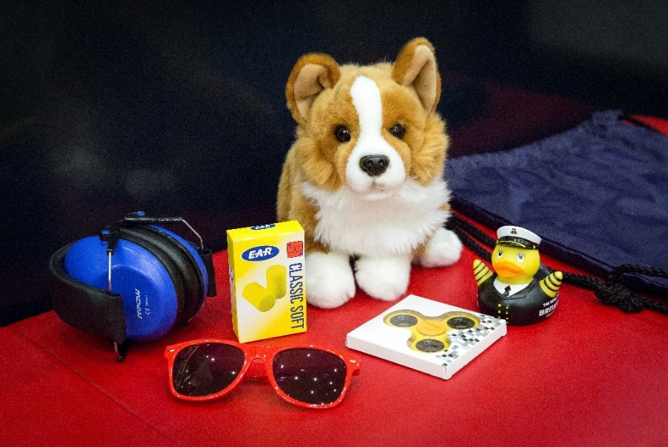

(Sensory pack)

Signage
General signage on board Britannia is white with navy blue text. The disc signs throughout the tour advise visitors which numbers to press on their audio handset tour and signify the colour of deck they are located on. Each deck has a colour, namely red, blue, gold, purple and grey.
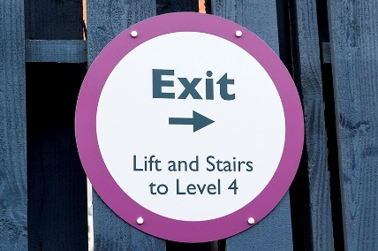
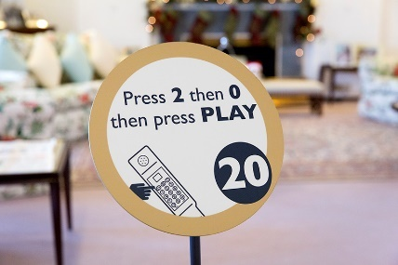
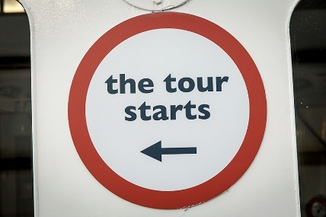

(Signs on the tour route.)

Britannia Tour (displays, exhibits)
- Many exhibits within the Visitor Centre and on board have a descriptive sign next to them in English.
- There are no displays that use flashing lights.
- There are Visitor Assistants located along the route who will be delighted to help with any queries or requests.
- There is background noise/music on the Bridge, in the Wardroom Ante Room, State Drawing Room, State Dining Room, Royal Marines’ Barracks, Chief Petty Officers’ Mess, Petty Officers’ Mess, Laundry, Royal Sailing Exhibition, Visitor Centre, Tearoom and Shop. Music is also played in the toilets on the Grey Level, and on the Blue Level on the Port side.
- Videos play in the Petty Officers’ and Royal Marine Sergeants’ Mess.
- To enhance the experience, scents are used in the Sick Bay (TCP) and Laundry (soap powder). Air fresheners are in use in all four toilets on board and in the Visitor Centre toilets. Additionally, as fresh food and fudge are prepared on board you may smell cooking on the Blue Level Port Side, Galley Corridor and near the NAAFI.

Public Access on board

Lift tower
A lift tower on the quayside gives access to Britannia’s five decks, with lifts to every level and ramps onto the ship.

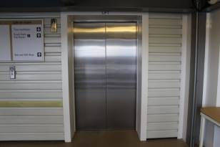

(One of two lifts in the Lift Tower.)

The lift tower takes visitors to all decks and opens at all levels. It is 1100mm in width.

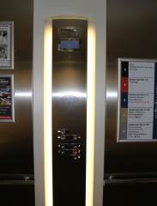
(Inside one of the lifts in the Lift Tower.)

Onboard lift to the Royal Deck Tearoom
The original lift on board Britannia has a manual opening/shutting door and an automatically closing inner door. (Please note that the manual doors are heavier to open/close). The door width is 750mm. This lift offers access to the Royal Deck Tearoom and State Apartments.

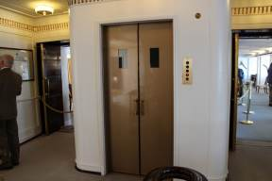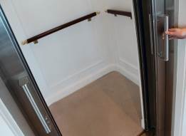
(Both images above show the onboard lift. On the left shows the lift at the State Apartments level. The image on the right shows the inside of the lift.)
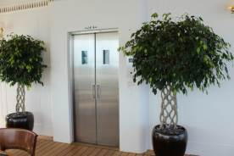
(The lift doors as seen from within the Royal Deck Tearoom.)

Inside the lift, there is a panel with buttons, please press the buttons on the left side. The maximum lift load is 1200LBS.

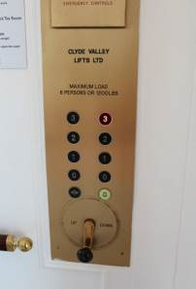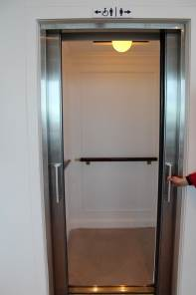
(The picture above on the left shows the buttons inside the lift. The image on the right shows the doors open at the Royal Deck Tearoom level.)

Doorways, floor coverings, lighting, stairs, ramps
Floor surfaces vary from wooden decks, short pile carpet, linoleum tiles to ceramic tiles. Lighting throughout Britannia is very good, with natural light and fluorescent and LED tube lighting.
There are a few access points to note:
- The doorway on exit from the Officers’ Wardroom is 780mm width and has a light wooden door.
- There are 2 ramps allowing access to the Verandah Deck, with handrails either side.
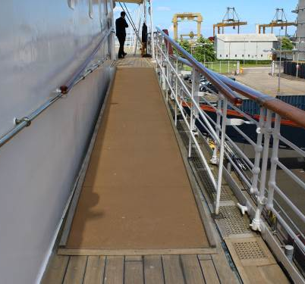
(Ramps aboard Britannia leading away from the Verandah Deck.)

- If the lift is not required to access The Royal Deck Tearoom, there are external stairs up from the Verandah Deck. There are 15 stairs, with handrails either side. These stairs are original, and narrower in depth than the other staircases on board.

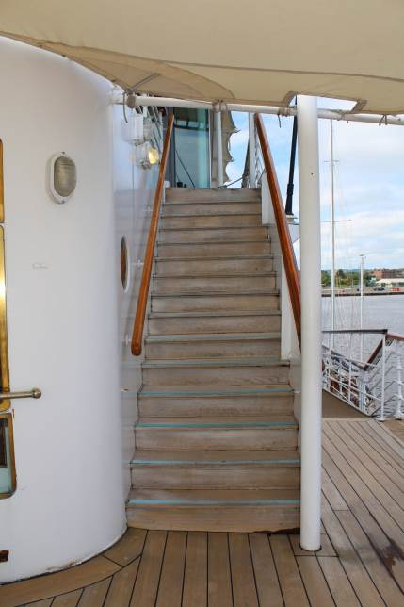
(Stairs to The Royal Deck Tearoom.)

Public Toilets
There are toilets situated on four levels aboard Britannia and in our Visitor Centre in Ocean Terminal.
The toilets in the Visitor Centre are located after the ticket desk and prior to boarding.

Visitor Centre
Door width: 900mm
Distance from seat: 1500mm
Seat height: 465mm

Tearoom
Door width: 1000mm
Distance from seat: 1200mm
Seat height: 465mm

Sailing Exhibition
Door width: 860mm
Distance from seat: 1000mm
Seat height: 490mm

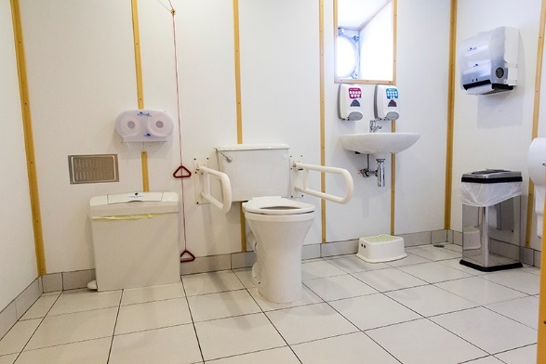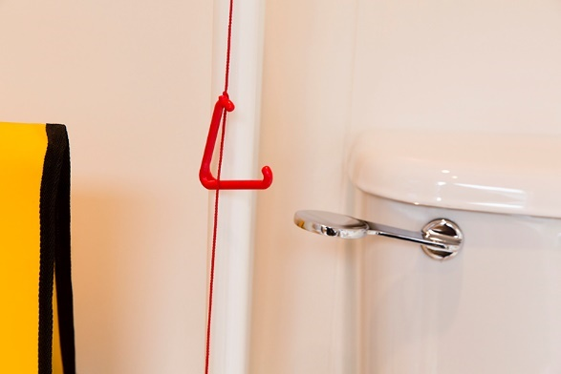

Gold level
Door width: 800mm
Distance from seat: 1200mm
Seat height: 560mm

Grey level
Door width: 800mm
Distance from seat: 1400mm
Seat height: 510mm
Please note, there is a slight slope in this toilet, due to the camber.

Royal Deck Tearoom
The Royal Deck Tearoom is situated on board Britannia. It is highly accessible for wheelchairs and buggies less than 670mm in width by internal lift from outside the Royal Bedrooms. The Tearoom is not accessible by Shopmobility scooters. The tables and chairs are moveable for wheelchair access.

- There are 15 steps up to the Tearoom from the Verandah deck. The door width is 1010mm and has a raised lip, which is highlighted with tape.
- The Tearoom has 35 tables and can seat 133 people. Table height is 720mm with chairs without arms. Guests are waited on with table service, by our staff.
- There are floor to ceiling windows throughout, as well as spotlighting.
- The flooring is original wooden deck.
- Our staff will happily read out the menu to customers. A magnifying glass and reading glasses are available, on request. Please ask a member of our staff.
- Crockery is white, with silver teapots. Our table tops are cream coloured. There are accessible WCs within the Royal Deck Tearoom.
- There are high chairs available for younger children and baby changing facilities.

Dietary requirements
- The menu caters for vegetarians and vegans and there are gluten free and dairy free cakes, scones, soups and sandwiches available.
- We also have gluten-free bread available for our sandwiches and our potato wedges are gluten and dairy free (the accompanying dip is not dairy free). There are gluten-free fruit scones and gluten and dairy-free cakes.
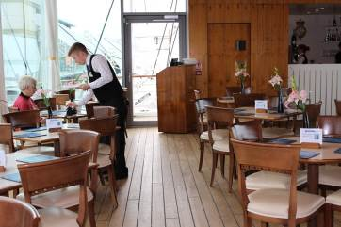

(Royal Deck Tearoom showing spacing between tables.)

Gift Shop
- Britannia’s Gift Shop is located within Ocean Terminal shopping centre, adjacent to the Visitor Centre entrance and can be accessed at the end of the tour, or directly from Ocean Terminal without having to visit Britannia itself.
- Access from Ocean Terminal is via an open doorway with a width of 2700mm. On exit from the Britannia tour, the entrance to the Gift Shop is 1700mm in width.
- The flooring within the shop is wooden and level throughout. The tables and fixtures have spacing throughout to enable wheelchairs/pushchairs to browse the shop. Fixtures include shelving units, tables and gondolas.
- A magnifying glass is available to borrow from the till point.

There is background music in the shop and a Britannia DVD, which plays on a screen, with sound. There is a hearing loop system within the shop. Britannia staff are happy to offer any assistance where required.

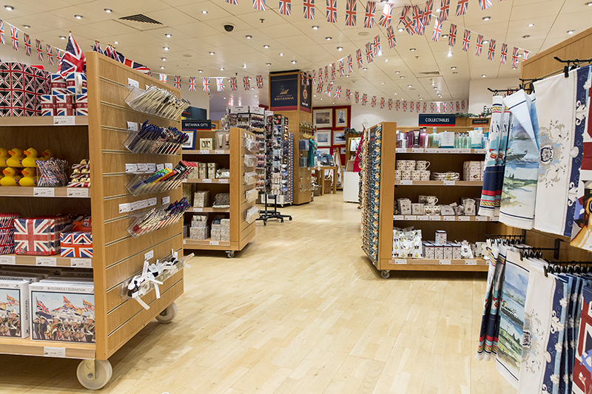
(Britannia Gift Shop, showing spacing between gondolas.)
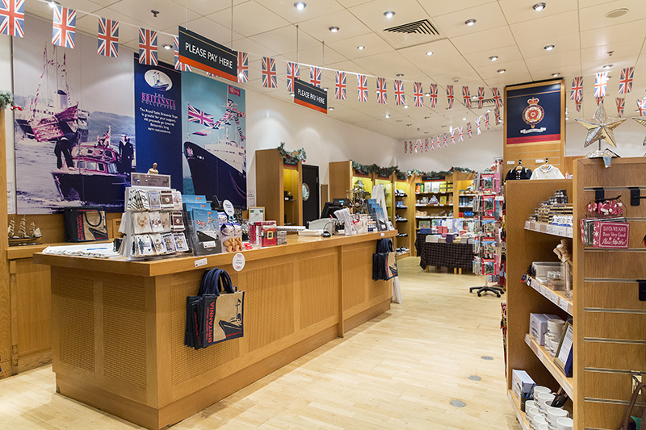
(Britannia Gift Shop and one of two till points.)

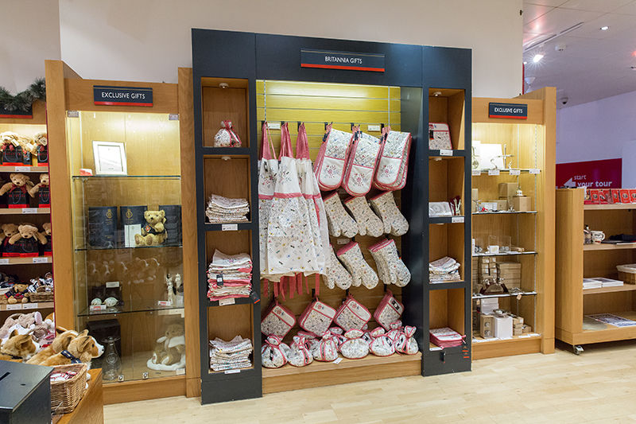
(An example display of shelving.)

The height of the highest shelf within the Gift Shop is 1750mm. Our staff are happy to offer assistance to reach any items within the shop.

Additional Information

Wheelchairs
If you are a wheelchair user and the measurements of your wheelchair exceeds 670mm we are happy to offer you a loan of one of our five wheelchairs, available free of charge. Please note our wheelchairs do not have lap seat belts. Our staff are positioned throughout the tour to answer questions and provide general assistance.

Assistance Dogs
Assistance dogs are welcome on board Britannia. We have dog water bowls located in the Visitor Centre, by our Reception and outside by the Royal Barge, next to the statue of a Former Royal Yachtsman. Should your dog require the toilet, please ask a member of our team who will be happy to escort you to our onboard facilities.

Evacuation Chair
In the event of an evacuation on board, we have an Evac Chair – The World’s No.1 Stairway Evacuation chair, which trained members of our team will administer on the day from the Tearoom.
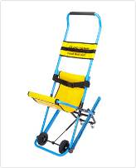
(Evacuation chair.)

Staff training
There is an ongoing programme of training with our staff.

First Aid
There is a first aid room on board and there are members of staff who are trained in general first aid.

Smoking Area
Smoking is not permitted within the Visitor Centre or on board. There is however a designated smoking area outdoors, next to The Royal Barge.

Local accommodation providers
The Holiday Inn Express is the nearest hotel to Britannia.
Holiday Inn Express, Britannia Way, Ocean Drive, Leith, Edinburgh, EH6 6JJ.

The Holiday Inn Express is 0.3 miles from Britannia. The Holiday Inn Express has 9 double accessible rooms with wheel-in access shower rooms. All rooms have flashing fire alarms, emergency lighting and emergency pull cords in both the bedroom and bathroom area. They also have a vibrating pillow that can be moved from room to room, which is linked to the fire alarm system to alert people who are deaf or have hearing loss should the fire alarm be activated. There is also an ‘Evac Chair’ so that disabled guests can evacuate the building in the event of a fire.

There are no accessible twin-bedded rooms, however there are adjoining rooms for carers which are provided free-of-charge. Please note that these interconnecting rooms must be booked directly with the hotel to ensure availability.

There are no stairs at the entrance to the hotel. The reception desk has a lowered area. Both the bar and breakfast room are on the ground floor with easy access.
Contact details for The Holiday Inn Express:
http://www.expressedinburgh.co.uk/

Feedback
If you would like to provide us with any feedback on this Access Statement, we would welcome your comments. We would be interested to hear if there is any information we may have missed that would be of interest. Please email us: enquiries@tryb.co.uk or by telephone +44 (0) 131 555 8800 or simply speak to a member of our team when you visit Britannia.

Contact Information
Address: The Royal Yacht Britannia, Ocean Terminal, Leith, Edinburgh, EH6 6JJ
Telephone: +44 (0) 131 555 5566 / +44 (0) 131 555 8800 (Mon-Fri, 9am-5pm)
Email: enquiries@tryb.co.uk
Website: www.royalyachtbritannia.co.uk

